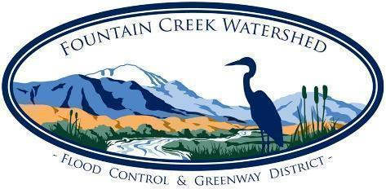

**Fountain Creek Watershed, Flood Control, and Greenway District   
Board of Directors, Water Activity Enterprise Meeting Agenda   
May 17, 2024 9am**

**In Person at Fountain City Hall, 116 S. Main Street, Fountain, CO 80817, or**

**Via Zoom: Zoom Meeting link:** [**https://us06web.zoom.us/j/89493089235**](https://us06web.zoom.us/j/89493089235)

**Meetings are open to the public.**

1. **Call to order, roll call, and establishment of a quorum**
2. **Introduction of Guests**
3. **Approval of May WAE Agenda**
4. **Consent Calendar**These items listed below are considered routine and will be acted upon as a whole unless a specific item is called for discussion by a Board Member or citizen wishing to address the Board. Any items called for separate consideration shall be acted upon following Public Comment.
   1. Approve minutes of prior WAE meeting:
      1. April 19, 2024
   2. WAE Financial Report
   3. Monetary Mitigation Fund Advisory Committee Report
   4. Approval of Invoices. There are sufficient funds to cover this item:

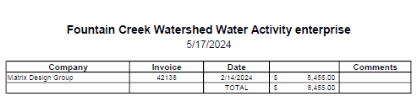

1. **Presentations** - None
2. **Old Business**
3. **New Business**
   1. Pueblo Levee Change Order
4. **Executive Session** - None
5. **Public Comments**

Citizens may address the District Board on items that are not on the agenda. The Board may not be able   
to provide an immediate answer but will direct Staff to follow up. Out of respect for the District and others in attendance please limit your comments to 3 minutes or less.

1. **Confirm Next Meetings - ALL MEETINGS NOW HYBRID!  
     
   Via Zoom or in person at Fountain City Hall (116 S. Main St. Fountain, CO 80817)**
   1. June/July - no meetings (7.17 USAFA Tour - RSVP needed)
   2. Fri Aug 16, 9am
   3. Fri Sept 20, 9am
   4. Fri Oct 18, 9am - Draft CIP presentation
   5. Fri Nov 15, 9am - Budget Hearing
   6. December - no meeting
2. **Adjourn WAE Meeting**